Sample table employees:

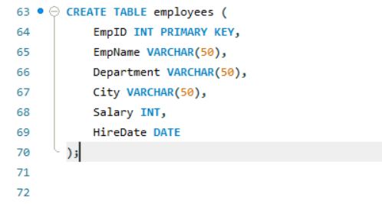

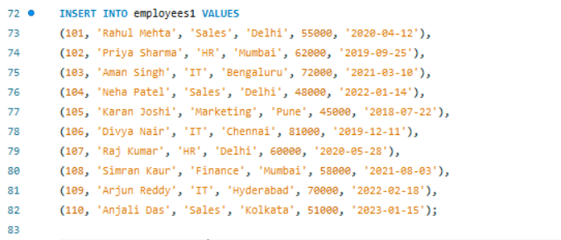

Question 1 : Show employees working in either the ‘IT’ or ‘HR’ departments

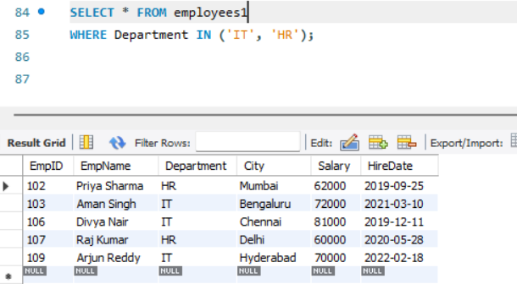

. Question 2 : Retrieve employees whose department is in ‘Sales’, ‘IT’, or ‘Finance’.
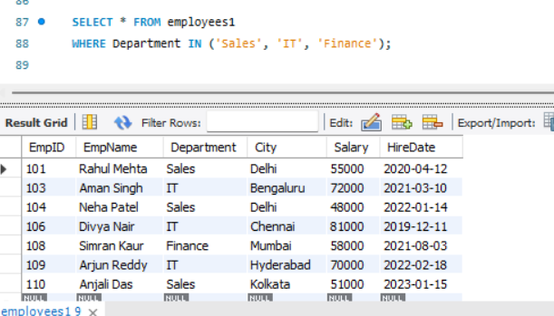

Question 3 : Display employees whose salary is between ₹50,000 and ₹70,000.
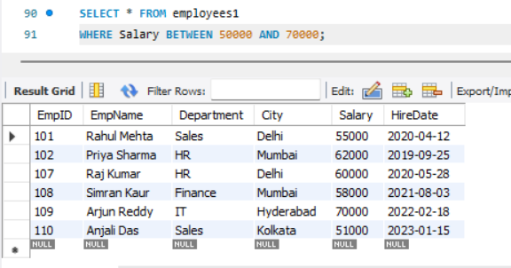

Question 4 : List employees whose names start with the letter ‘A’.
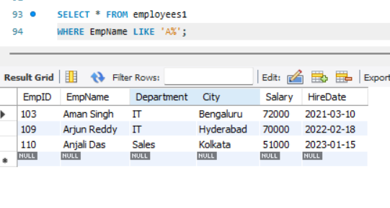

Question 5 : Find employees whose names contain the substring ‘an’
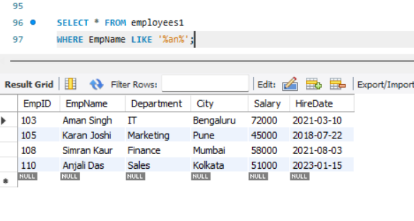
Question 6 : Show employees who are from ‘Delhi’ or ‘Mumbai’ and earn more than ₹55,000.
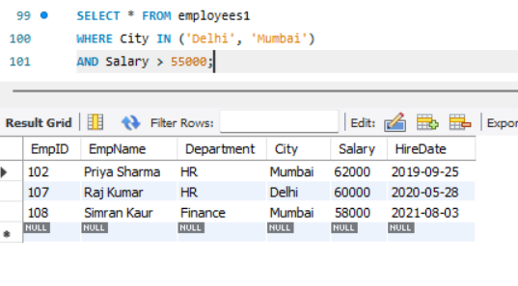

Question 7 : Display all employees except those from the ‘HR’ department.
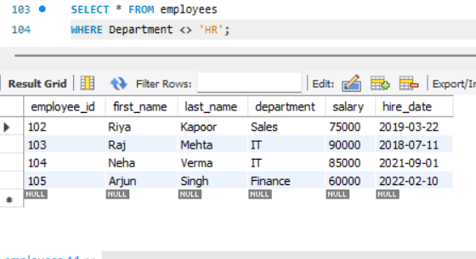

Question 8 : Get all employees hired between 2019 and 2022, ordered by HireDate (oldest first).

